EXPERIMENT.NO:5
DATE : 13.2.2026
Title
To design and understand the working of a Library Management System using UML Class Diagram and Sequence Diagram.
Introduction
The Library Management System is designed to manage library activities such as book issuing, member registration, transaction handling, and department management. It provides features like book availability checking, member verification, transaction recording, and fine calculation.
The system is divided into the following main components:
- Library
- Librarian
- Member
- Book
- Transaction
- Department
Class Diagram – Text Representation
Class: Library
Name:String
Address : String
Methods:
addBook()
registerMember()
Class: Librarian
employeeId : int
Methods:
addBook()
blockMember()
Class: Book
ISBN:String
Title:String
Author:String
isAvailable : Boolean
Method:
reserve()
Class: Member
memberId:int
Name : String
Methods:
borrowBook()
returnBook()
Class: Transaction
issueDate:Date
dueDate : Date
Method:
calculateFine()
Class: Department
deptName:String
HOD : String
Sub-Departments:
IT, CSE, MECH, CIVIL, ECE
Diagram:
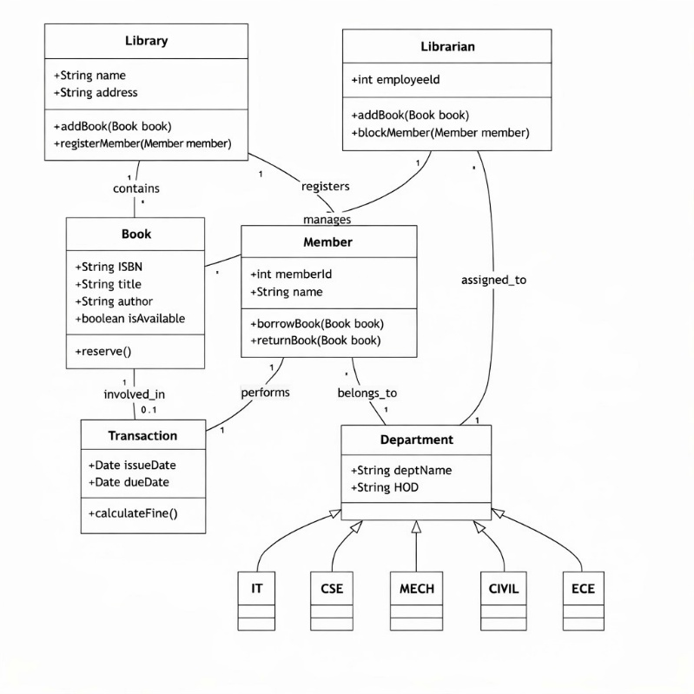
Relationship Description
- Library → Book (Contains)
- Library → Member (Registers)
- Librarian → Member (Manages)
- Member → Transaction (Performs)
- Member → Department (Belongs to)
- Book → Transaction (Involved in)
- Librarian → Department (Assigned to)
These relationships define how different components interact and depend on each other.
Sequence Diagram – Process Flow
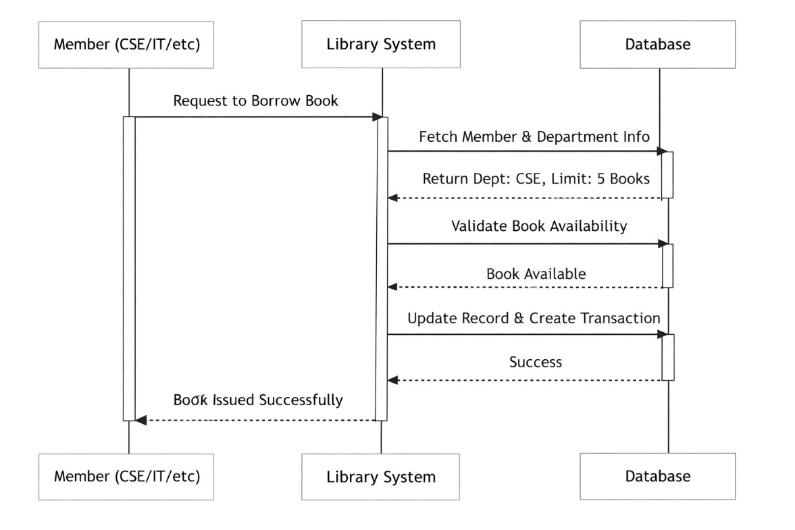
Book Borrowing Process Steps:
- Member sends request to borrow a book
- Library System receives the request
- System fetches member and department details
- Database returns borrowing limit
- System checks book availability
- Database confirms availability
- System updates record
- Transaction is created
- Confirmation is sent to member
- Book is issued successfully
This process ensures secure and systematic book issuing.

System Advantages
The workflow follows a structured and secure pattern:
- Easy book management
- Secure member verification
- Accurate transaction recording
- Automatic fine calculation
- Reduced manual work
- Faster processing
Applications
- College libraries
- School libraries
- Digital libraries
- Research institutions
- Public library systems

Conclusion
In conclusion, the UML diagrams effectively represent the structure and functioning of the Library Management System. The Class Diagram defines the system components and their relationships, while the Time Sequence Diagram explains the operational flow of book issuing. The system follows a logical, modular, and secure approach, ensuring efficient management of books, members, and transactions. This design helps in improving library services and user satisfaction.

